**Procurement Management**

1. Importance
2. Make or buy decision
3. Types of contracts
4. Procurement cycle

**Procurement Management**

1. The acquisition of products or services not produced or delivered by the project team
2. May require the assistance of experts
3. Your project may be on the other side also—providing services to another 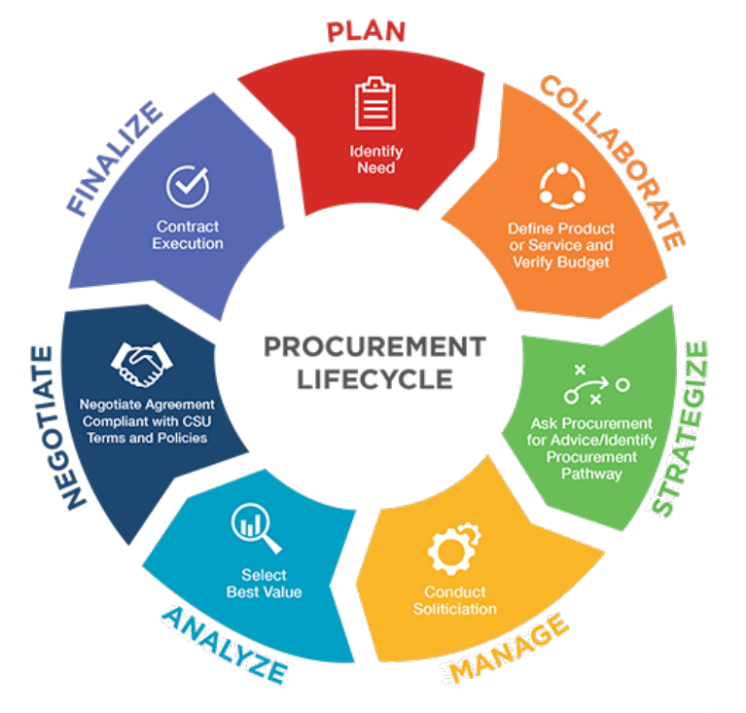organization
4. Legal implications of signing a contract
5. The make-or-buy decision
   1. Expertise
   2. Resource availability
   3. Licensing, regulatory requirements
6. Fixed Price
7. Cost reimbursable
8. Time and materials

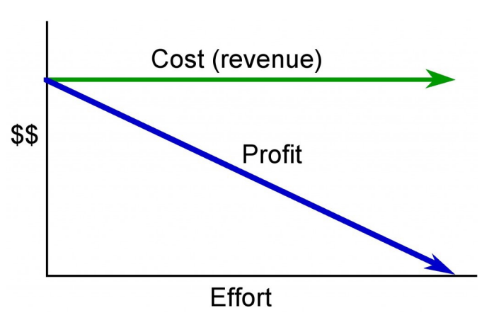**Fixed Price Contract**

Fixed-price contract the cost is constant regardless of the effort applied or the delivery date

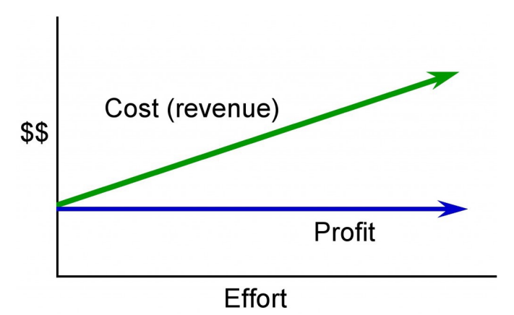**Cost Reimbursable Contract**

In a cost-reimbursable or cost-plus contract,

the seller is guaranteed a fee

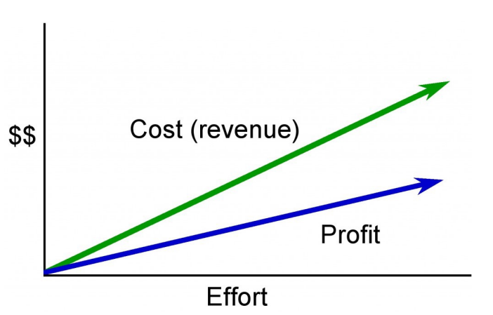**Time and Materials**

In a time and materials contract the cost

(or revenue to the vendor) increases

with increased effort

**Fixed Price Contract types**

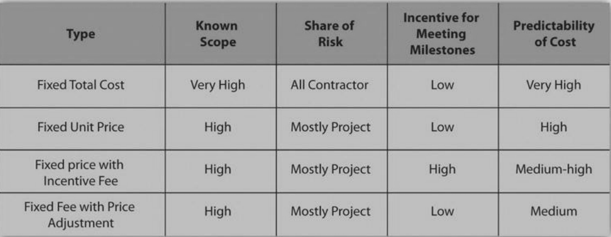

**Cost-Reimbursable Contract Types**

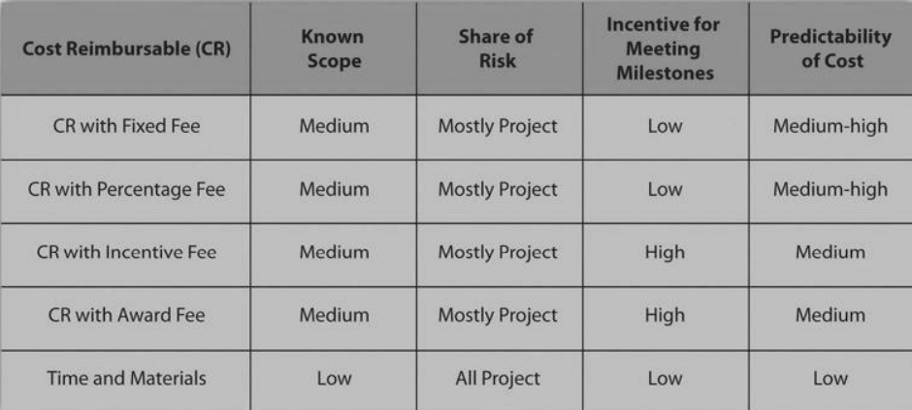

**Procurement Cycle**

1. Procurement Plan
2. Selecting the Contract Approach
   1. Skill level, uniqueness
   2. Type of relationship: supplier, vendor, partnership
   3. RFP, RFQ, personal contact
   4. How well-known is the scope of the work?
   5. Risks—what are they? Who assumes them?
   6. How much float if any?
   7. How important to be sure of cost in advance?
3. Soliciting bids
4. Qualifying bidders
5. Request for Quote (RFQ)
6. Request for Proposal (RFP)
7. Evaluating the bids
   1. Usually a matrix approach
   2. Cost is NOT the only consideration
8. Awarding the contract
9. Managing the contracts
10. Logistics and expediting
11. Change coordination

**Procurement Management Summary**

1. Make or buy analysis
2. Contract types
   1. Fixed Price
   2. Cost reimbursable
   3. Time and materials
3. The Procurement Cycle
   1. Bidder qualification
   2. RFP or RFQ
   3. Analysis and selection
   4. Contract negotiation
   5. Contract administration
   6. Contract closure

**Chapter Summary**

1. Procurement is an important activity for project managers
2. Procurement management includes deciding about contracts and relationships with vendors, suppliers, partners
3. All stages of procurement should be closely monitored
4. Reporting to the team and to management are important components in budget and procurement management